Installation of Python

Step 1:

[https://www.python.org/downloads/](https://www.python.org/downloads/" \t "https://chat.openai.com/c/_new) and download the latest version of Python for your operating system

(Windows, macOS, or Linux). Ensure you download the version that includes IDLE.

Step 2:

****Run the Installer****:

For Windows:

* After downloading, run the installer (it will have a filename like **python-X.Y.Z.exe**, where **X.Y.Z** represents the version number).

Step 3:

Click Windows+R----->Command Prompt

Type Python in the Command Prompt and the result as shown below with installation details.

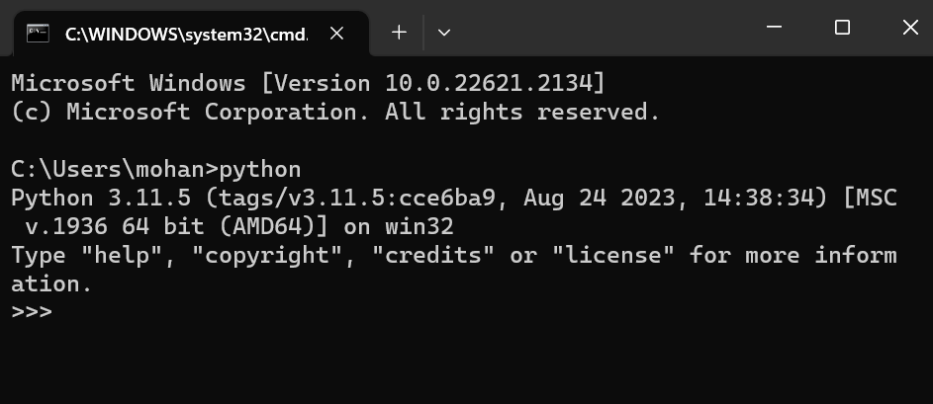

Step 4:

To verify that Python IDLE is installed, open a terminal or command prompt and type:

Click Windows+R----->Command Prompt

Type

Python -m idlelib.idle

IDLE Shell

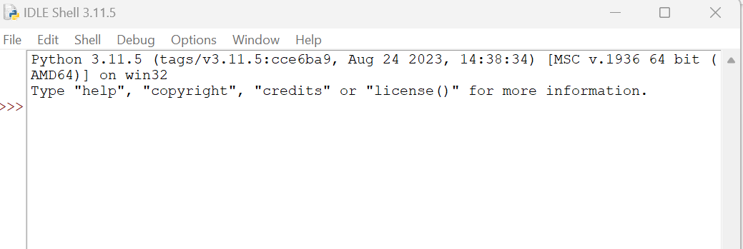

Step 5:

Click File-->open New File

Type your python program

Step 6:

Save the file by FileName.py

Step 7:

Click Run Tab and run the module